‘Celebrating The Arts’

Gallery Window on Mayfield High Street

Aims/ Objectives
- To provide an opportunity for new and emerging artists with talent to get exposure and feedback about their work;
- To provide an opportunity for local artists who lack local exposure to promote and showcase their work in the local community;
- To give the local community an opportunity to be inspired by work from a range of artists and mediums;

Application Guidance & Process:

Criteria & Conditions:

- Must be living locally to TN20 area (East Sussex/ Kent border);

- All applications and decisions will be processed via a committee;

- There will be opportunity for approximately 8 – 10 artists to exhibit each year;

- Work exhibited must be finished and framed to an exhibiting standard;

- Artist’s contact details will be on display and artists must manage their own sales;

- Artist is responsible for mounting/ hanging work and must bring tools and equipment needed;

- Artist is responsible for taking down work and putting space back to how they found it;

- Artist is encouraged to promote exhibition via social media;

- There will be no access to the gallery window for the duration of the show as there is a working office behind the window which cannot be continually disturbed;

- 10% of any sales made must be donated to MAYFACS (a local charity supporting emotional well being through workshops and practical support, tackling isolation & loneliness);

To Apply:

Send 3 good quality images of your current work (work which you propose to exhibit) to
theartsfair@gmail.com
Please put Mayfield Gallery Window application as the title of your email.
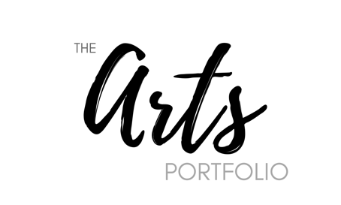
Good Luck!

